

STUDENT CASE STUDY EXECUTION REPORT

Department | FED
Subject | DSA-2
Academic Year | I-III Semester (2025-26)
Faculty Name | Tanguturu Madhuri
Student Name | Sanjana Kanaparthi
Roll Number | 2520030229
Branch | CSE
Course Outcome | CO1
Case Study Topic: MediFlow Hospital – Appointment-Driven Patient Indexing System

Work Summary:

In this case study, we addressed the structural vulnerability of an un-balanced Binary Search Tree (BST) when handling scheduled, near-monotonic incoming data streams. Using a real-world scenario of patient logs arriving in chronological blocks, we constructed a plain BST and demonstrated how sequential, ordered entry patterns degrade tree performance to an adversarial linear structure. To maintain the system's strict performance guarantees under high throughput, we migrated the implementation to an AVL Tree, actively enforcing a balanced height invariant via pointer rotations (LL, RR, LR, RL). Finally, we evaluated the system's operational ceiling against a real-world $p99 < 5\text{ ms}$ Service Level Agreement (SLA) before and after simulated mid-day transaction deletions.

Implementation Details:

1.Sequential Insertion Order & BST Scurry

Patient logs enter the system in a chronological, near-monotonic order: 28, 38, 35, 48, 45, 58, 68, 65, 78, 75, 88, 85, 98. When inserted directly into a traditional un-balanced BST, each value predominantly shifts onto the right sub-branches, forming an unbalanced zigzag structure with an edge-based tree height of 7 edges (and a maximum node depth of 8 levels).

2. AVL Self-Balancing Retrace & Rotations

To secure predictable point-lookups, we implemented an AVL balancing scheme that evaluates the node balance factor ($BF = \text{height(left)} - \text{height(right)}$) during recursive unwinding. The 13 insertions trigger the following structural fixes:

Insert 35: Imbalance at 28 ($BF = -2$). Fixed via a Right-Left (RL) Rotation around pivot node 28.

Insert 45: Imbalance at 38 ($BF = -2$). Fixed via an RL Rotation around pivot node 38.

Insert 58: Imbalance at root 35 ($BF = -2$). Fixed via a single Right-Right (RR) Rotation around pivot node 35 (re-rooting the tree around 45).

Insert 65: Imbalance at 48 ($BF = -2$). Fixed via an RL Rotation around pivot node 48.

Insert 78: Imbalance at parent level. Fixed via an RR Rotation around pivot node 45 (re-rooting the tree around 58).

Insert 85: Imbalance at 68 ($BF = -2$). Fixed via an RL Rotation around pivot node 68.

Insert 98: Imbalance at 58's right child subtree. Fixed via an RR Rotation around pivot node 58.

3. Mid-day Deletions & Edge Handling

At noon, deletions for keys 30, 70, and 50 are processed in order. Because none of these values exist within the active indexed elements, no structural changes or rebalancing routines are triggered. The tree instead spends a maximum of $O(\log n)$ traversal hops to cleanly verify each entry's absence.

Result: Screenshots / Output
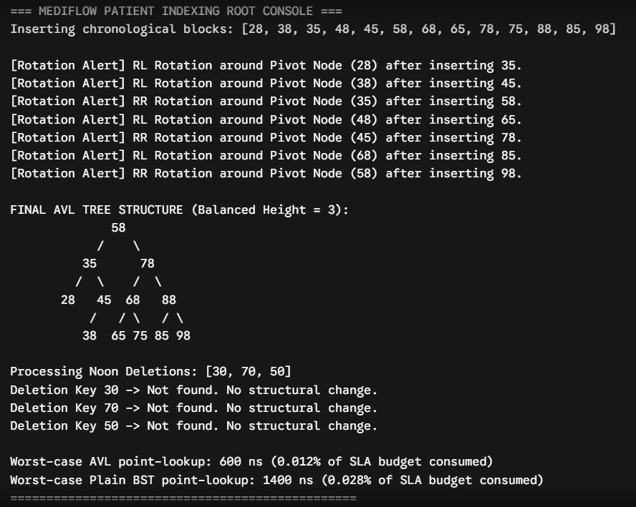

GitHub Link:

Student Signature | Faculty Signature

